00The hidden gem right on your door step…….
OAK AND FURROWS OPEN DAY, SATURDAY 19TH SEPTEMBER 2015
I’m guessing many of you have done it. Found an ailing fledgling, injured bird, poorly hedgehog, or otherwise hapless and/or damaged member of Mother Nature’s Wildlife Community. You wanted to help. But didn’t know what to do…..
So, two things. First thing is, that’s where the wonderful Oak and Furrows Wildlife Centre come in! And secondly, they’ve had an Open Day and official opening of their new premises, which you may or may not have known about! And THEY are the experts where Wildlife Rescue are concerned….
Now, for your enlightenment and enjoyment, allow me to disseminate some information which may, at some point be more than useful (see above…..) in the future, but informative and entertaining to boot….
To continue…..
The Centre was originally founded by Serena Stevens in 1994 (way, way beyond my time….) and it became a registered charity in 2006. Originally, at Somerford Keynes but recently relocated to the Blakehill Nature Reserve on the road between Minety and Cricklade. Every year, the Centre takes in over 3,000 casualties, as well as receiving thousands of telephone calls from people seeking help and advice. The staff and volunteers are dedicated to treating sick, orphaned and injured creatures. Those animals and birds (plus anyone else feathered, furry or otherwise not mentioned above….) who have been rescued are then, following expert and dare I say, loving care, released back into their natural environment. Working with other agencies, vets, the RSPCA and the Police, Oak and Furrows continues to rescue and assist these helpless wildlife casualties. They are also available to visit schools and other groups, (err the Centre Staff, and not the incumbents), to educate everyone in the needs of wildlife, how to care for the immediate needs of injured creatures and how to recognise if the individual (creatures and birds I mean…..) require human intervention ie HELP!!!! Or not……
There is more, so much more which I could say but, I seek not to lose you, my audience….. So, back to the Main Event!

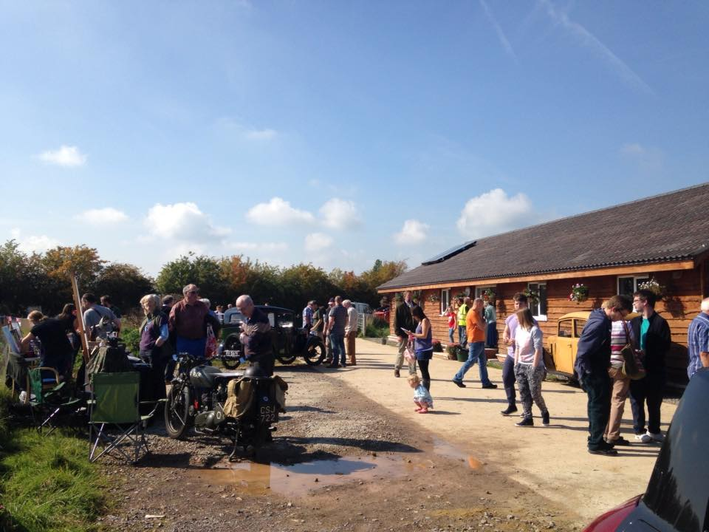
This Open Day…. The weather was nothing short of fabulous! The sun shone and those tiresome rain laden clouds which had dogged the earlier part of the week, melted away to make room for warm Indian Summer Sunshine. The Patron, the wonderful Pam Ayres, poet, celebrity and icon to many of a “certain age”, fond of a ditty and taller than anticipated, (but then most people are taller than me….) officiated at the Opening Ceremony, cut the ribbon and unveiled the splendid plaque displaying the name of the Charity. She then spoke with great affection of her own love of wildlife, its importance to the local community and the environment, concluding with one of her poems, which have made her so famous, and well, loved!!!!!
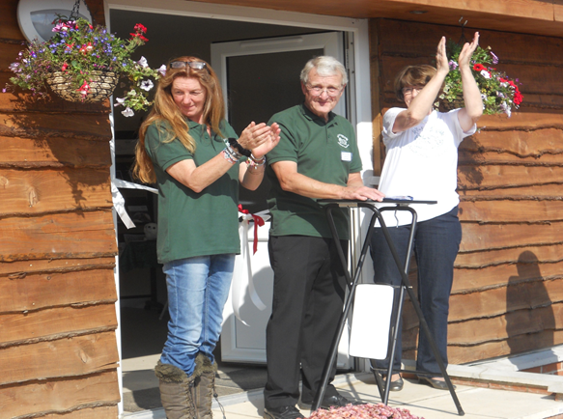
Serena Stevens, Barry Branigan and Patron Pat Ayers during Speeches
The other speakers, who I shall mention almost in passing, but whose contribution was great, were Dr Gary Mantle, CEO of Wiltshire Wildlife Trust, and Barry Branigan, General Manager of the Centre. Serena was recognised for her huge dedication of 21 years (and counting) to wildlife, and Ray Hood was also flagged up for further dedication beyond the call of duty, in project managing the relocation from the old site to the new one. But, away from the speakers, there was much also of interest….
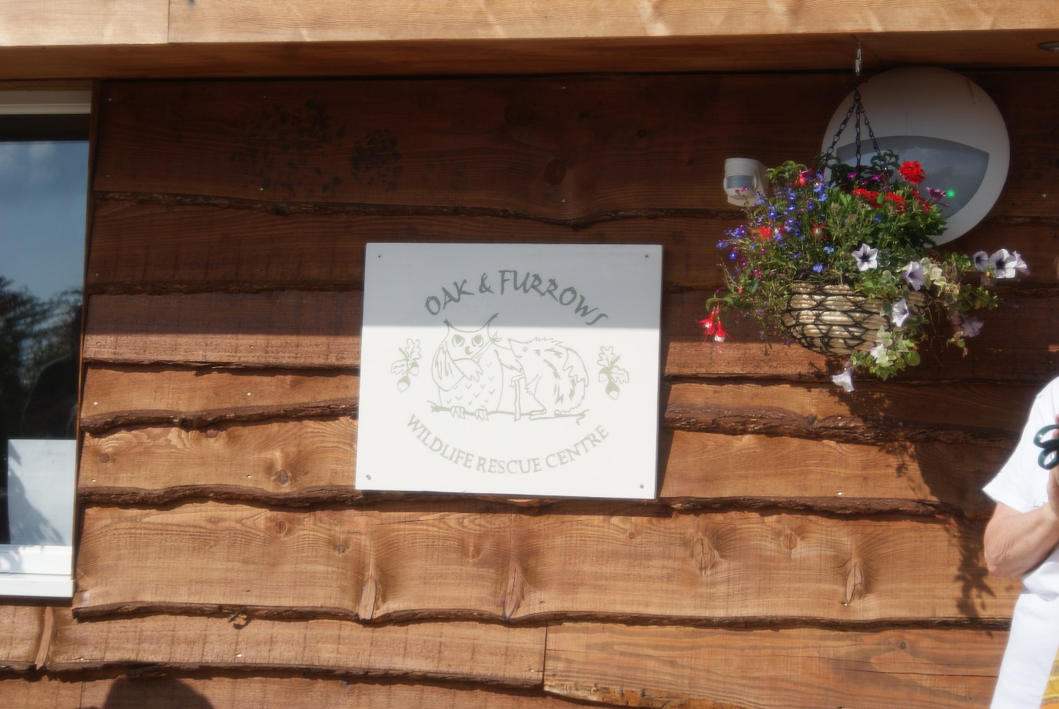
The Opening Ceremony Unveiled this Sign
The visitors saw the newly built facilities, a splendid Visitors Centre, saw some of the lucky patients (depending upon how you view it…), enjoyed a fabulous plant stall, cake stall to shake even the most committed dieter, a raffle with some tremendous prizes and various activities for children, young and not so young!!!!
Top prize for the “Impossibly Cute Current Residents”, went to the numerous Hedge Hoglets…. They also won the prize for, “Small, But More Smelly Than Anticipated, Even Though Impossibly Cute” section! However, there is no doubt that these loveable, and welcome garden visitors (if you are a gardener that is, and not perhaps a slug…..), are fewer than they used to be and are definitely deserving of as much of our help as possible! So, that, in an organic nutshell, is the lowdown on the Open Day! And by the way, it raised around £3000 on the day!
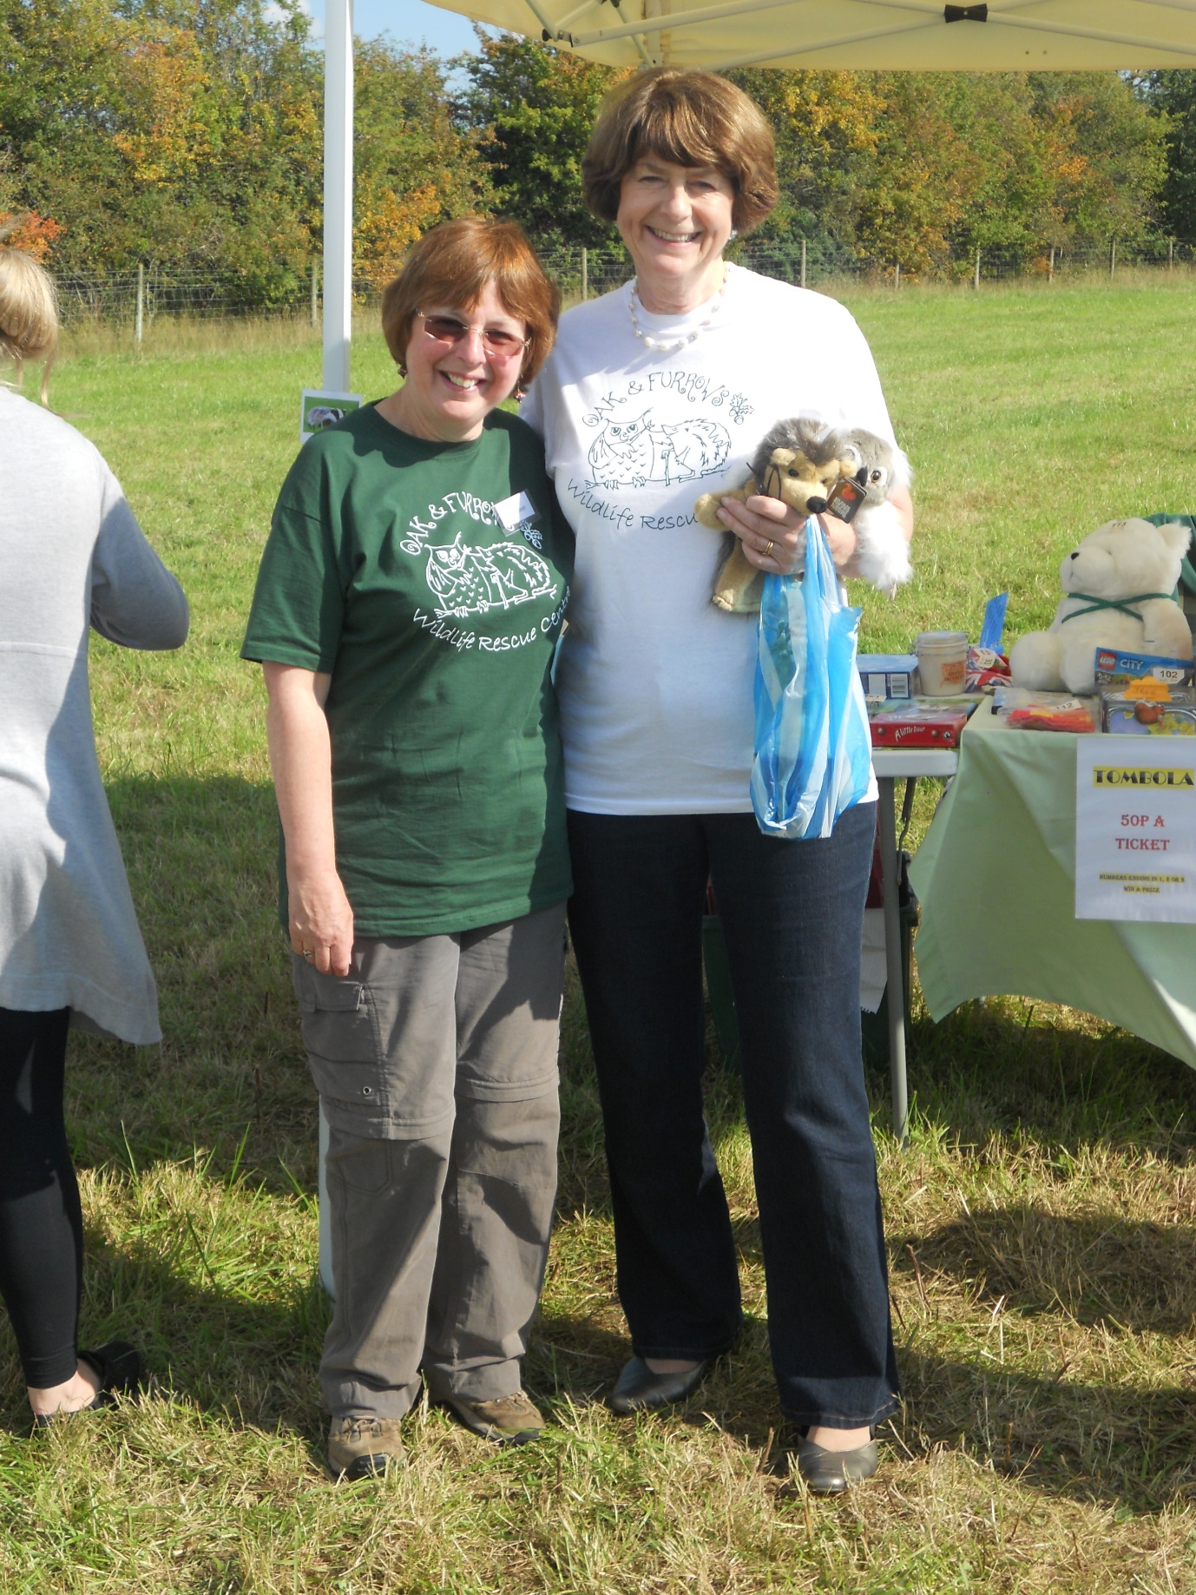
Patron Pam Ayers with one of the Oak and Furrows Volunteers
So my audience, I leave you with the thought that Wildlife is all around, from small to large and if it does need help, then the wonderful Oak and Furrows is there to assist! I do hope you enjoyed my missive and that there will be more from me soon….. But, for reference, if you need them, the lovely people at the Wildlife Centre can be contacted by email on oakandfurrowswrc@msn.com or 01793 751412.
Until next time, with warmest wishes, Basil the Badger

